Predicting bird diversity along a broadleaf gradient
Brendan Casey
2024-05-19

Introduction
Here we describe our work predicting bird diversity along a gradient of percentage broadleaf cover using recent Government of Canada spatial data.

Background
Industrial forestry in North America has led to simplified even-aged conifer dominated forests (Venier et al. 2014, Brandt et al. 2013). In response, there is growing interest in promoting mixed conifer-broadleaf stands that balance timber production with environmental goals (Franklin and Johnson 2012, Huberman and Eskelson 2023). Comparative studies between mixed-wood and conifer-dominated stands suggest that mixedwoods support higher levels of biodiversity, provide more habitat for cavity-nesting species, and have greater forest productivity (Hobson and Bayne 2000, Cumming et al. 2014, Felton et al. 2021, Huberman and Eskelson 2023). While many studies have compared coniferous monocultures to mixedwood stands, few have examined mixedwoods along a coniferous-deciduous gradient or sought to identify deciduous thresholds that maximize biodiversity.

Objectives
To assess the influence of varying degrees of mixedwood on breeding bird communities, we will (1) examine how bird species diversity varies across a coniferous-deciduous gradient, (2) identify scale-dependent effects of mixedwood composition on bird communities, and (3) use, evaluate, and compare discrete measures of mixedwood composition from forest inventories, and continuous, pixel-based measures derived from satellite remote sensing.

Methods
To examine the influence of fractional broadleaf cover on bird diversity, we used mixed-effects regression models to assess how the proportion of deciduous tree cover influences the taxonomic diversity of birds across multiple scales (150 m, 500 m, and 1000 m). An overview of the methodological workflow is illustrated in Figure 1. All analyses were done using R statistical software (R Core Team 2020).
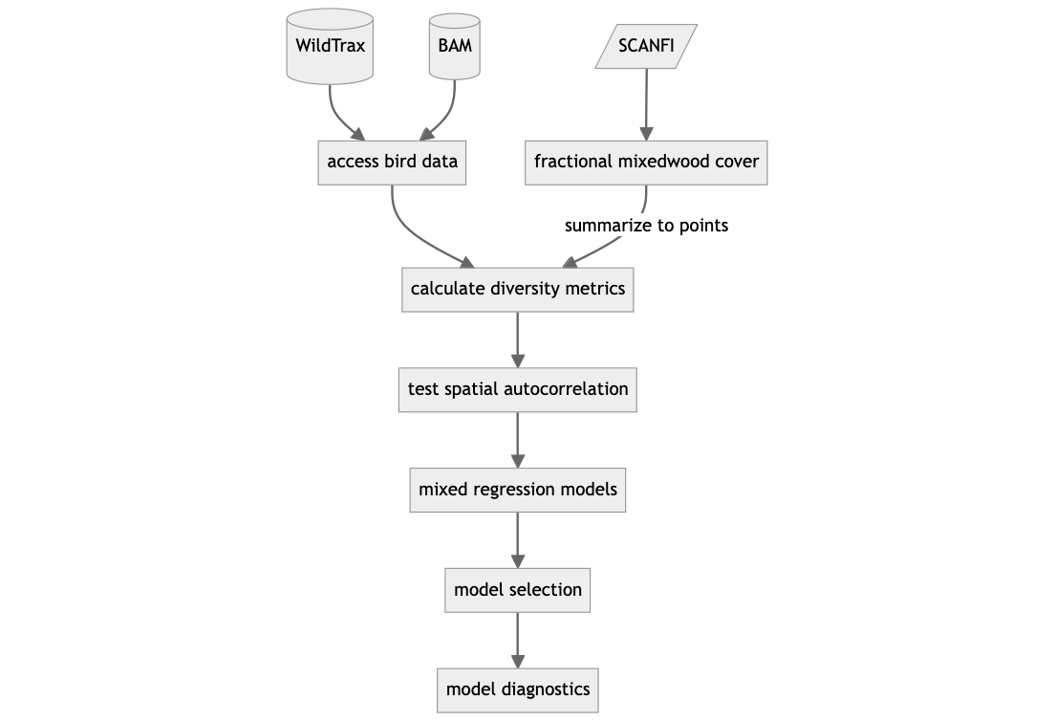
Figure 1: Diagram of the project’s methodological workflow.

Study area
We used human and automated acoustic point counts done across forested areas in Alberta, Canada, including the Rocky Mountain, Foothills, and Boreal Forest Natural Regions (Natural Regions Committee 2006) (Figure 2).
The Boreal Forest Natural Region spans most of northern Alberta. It’s composed of coniferous forests dominated by black spruce (Picea mariana), white spruce, and jack pine (Pinus banksiana), and mixedwood forests with trembling aspen and balsam poplar, and shrubby black spruce fens (Natural Regions Committee 2006). In the Rocky Mountain region, in western Alberta along the continental divide, vegetation composition changes along an elevation gradient. Higher elevations consist mainly of alpine shrub and meadow, while lower elevations host coniferous and mixedwood forests. Common tree species include lodgepole pine (Pinus contorta), white spruce (Picea glauca), Engelmann spruce (Picea engelmannii), subalpine fir (Abies lasiocarpa), and trembling aspen (Populus tremuloides). The Foothills Natural Region, at the eastern edge of the Rocky Mountains, serves as a transition between the Rocky Mountain and Boreal Regions. At lower elevations, the Foothills It is dominated by mixedwood forests of lodgepole pine (Pinus contorta), white spruce (Picea glauca), trembling aspen (Populus tremuloides), and balsam poplar (Populus balsamifera). Lodgepole pine forests are common at higher elevations (Natural Regions Committee 2006).

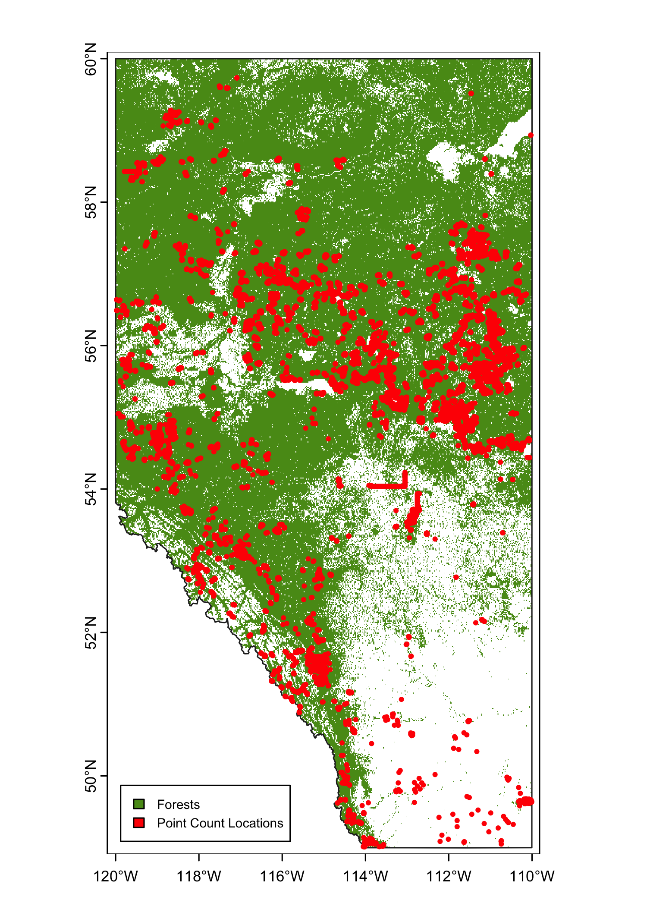
Figure 2: Locations of the point counts and acoustic surveys used in this analysis.

Response variables
We obtained point count data from the Boreal Avian Modeling Project (BAM) (Boreal Avian Modelling Project 2018) and the University of Alberta’s Bioacoustic Unit (http://bioacoustic.abmi.ca/). Point count data was accessed through www.wildtrax.ca using the wildRtrax package (MacPhail et al. 2024). Our study included both human and automated acoustic point count data from 74 research projects; 59513 point counts done across 14947 locations.
Data were filtered to include only records from morning point counts conducted between 30 minutes before sunrise and 5 hours after sunrise during the breeding season (May-July). We included point counts done within 10 years of the land cover data (i.e., after 2009) in coniferous, broadleaf, or mixed wood forests older than 10 years. To control for the influence of fire or harvesting on model performance, we excluded point counts done in forests that experienced stand-replacing disturbances between the time of the point count and the year of the spatial product.
Surveys were conducted within sampling radii ranging from 50 to 150 m and lasted 1 to 10 minutes. To account for differences in bird detection probability from varying sampling effort, we used the ${\text{log}}_{10}$ of sampling effort (i.e., the number of survey days multiplied by point count durations) as an offset term in the mixed regression models.
Site-level bird taxonomic diversity was computed for each point count location. We excluded flyover species and water birds, including grebes (Podicipediformes), pelicans (Pelecaniformes), ducks, geese, and swans (Anseriformes), and loons (Gaviiformes). For each point count location, we calculated species richness (Equation 1), the Shannon diversity index (Equation 2), and the Pielou’s evenness index (Equation 3). Species richness is the total number of species present. The Shannon diversity index measures the diversity of species in a community, accounting for both richness and the relative abundance of species. Pielou’s evenness index provides a measure of how evenly species are distributed in a community.
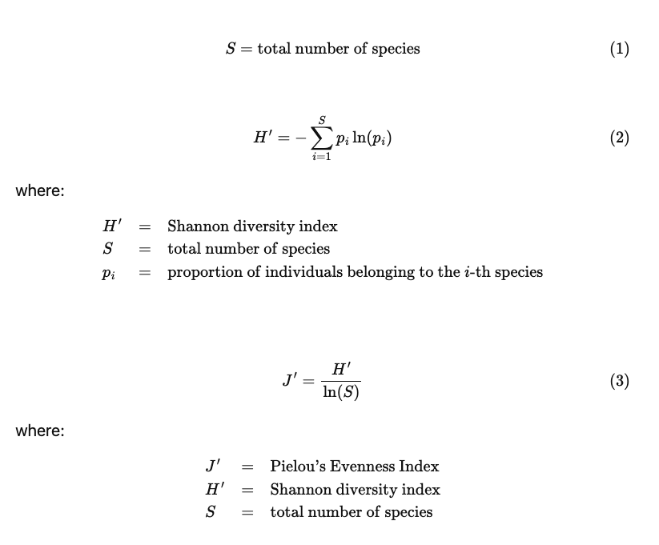
To assess spatial autocorrelation in response variables, Moran’s I statistic was calculated for different distance thresholds (from 0 to 30,000 meters in 500-meter increments) using the spdep R package. The results were plotted, and the inflection point—where the Moran’s I value flattens—was identified to assess the spatial autocorrelation pattern. To minimize the impact of spatial autocorrelation on model performance, point count locations were grouped into ‘site clusters’ based on the inflection point (5000 meters) using hierarchical clustering with the hclust function from the stats R package. Site clusters were used as a random effect in the mixed-effect models.

Predictor variables
We sourced predictor variables from the 2020 Spatialized Canadian National Forest Inventory (SCANFI) (Guindon et al. 2024). SCANFI is a collection of 30-meter resolution maps of forest attributes for Canada, including land cover type, forest canopy height, crown closure, aboveground tree biomass, deciduous tree cover, and fractional cover for several common tree species such as black spruce, jack pine, and lodgepole pine. SCANFI was developed using photo-interpreted high-resolution imagery, Landsat spectral imagery, and hundreds of regional land cover models (Guindon et al. 2024). See Table 1 for descriptions of the SCANFI predictor variables used in the analysis.
Table 1: The spatial covariates used in the mixed-effects regression models.
Variable | Description | Source
Land cover class | classes include broadleaf forest, mixedwood, conifer forests, shrub, and water | (Guindon et al. 2024)
Height | vegetation height (m) | (Guindon et al. 2024)
Crown closure | tree canopy coverage (%) | (Guindon et al. 2024)
Biomass | Aboveground tree biomass (tons/ha) | (Guindon et al. 2024)
Fractional broadleaf | Proportion of the canopy covered by broadleaf tree species (%). | (Guindon et al. 2024)
Age | Landsat-derived forest age for 2019 | (Maltman et al. 2023)
For all predictors, we computed focal statistics at 150 m, 500 m, and 1000 m using the focal function in the terra package in R (Hijmans 2024). For SCANFI rasters with continuous cell values, we computed the mean and standard deviation within each moving window. For categorical rasters (i.e. land cover class), we calculated the modal value within each moving window. All SCANFI focal statistics were summarized to point count locations using the extract function in the terra package in R. To improve model fitting and interpretation, extracted values were standardized (centered and scaled) by subtracting the mean and dividing by the standard deviation.

Statistics
We used mixed-effects regression models to investigate the impact of fractional broadleaf cover on diversity indices using the lme4 package in R (Bates et al. 2015). Poisson generalized linear mixed models with a log link function were used to predict species richness, while linear mixed models were used to predict Shannon diversity and Pielou’s evenness. The log₁₀​ of sampling effort was used as an offset to correct for differential sampling effort, with site cluster and point count location included as nested random effects.
We followed a stepwise modeling process for each response variable and SCANFI predictors summarized at different spatial scales (150 m, 500 m, and 1000 m). First, we assessed the linearity of predictor-response relationships by fitting separate models using linear, quadratic, and cubic terms for predictors. Second, we evaluated interaction terms between fractional broadleaf cover and forest age. Third, we fit a global model that included all potential predictor variables as fixed effects. Fourth, we addressed multicollinearity by calculating pairwise Pearson correlation coefficients and VIF scores for all predictors, iteratively removing highly correlated predictors from the global model. We kept only predictors with low correlation (r < 0.5 and VIF < 3). Fifth, we used the dredge function from the R package MuMIn to assess the performance of models containing combinations of the remaining predictors (Bartoń 2020). For each model, we calculated pseudo-$R^{2}$ as an indicator of model fit (Nakagawa and Schielzeth 2013). The model with the lowest Akaike’s Information Criterion (AIC) was selected as the top model (Burnham and Anderson 2002). To assess model quality and goodness-of-fit, model diagnostics were done using the check_autocorrelation() and check_model() functions from the performance package in R (Lüdecke et al. 2021). Last, for each model, 95% prediction intervals were estimated using parametric bootstrapping (500 iterations) via the bootMer function in the R package lme4 (Bates et al. 2015).

Results
To examine the influence of fractional broadleaf cover on bird diversity, we used mixed-effects regression models across multiple spatial scales (150 m, 500 m, and 1000 m). By integrating detailed SCANFI forest data with point count surveys, we could analyze the relationship between forest composition and bird diversity indices such as species richness, Shannon diversity, and Pielou’s evenness, and identify broadleaf cover percentages at which diversity indices are maximized.

Descriptive statistics
A total of 14947 point count sites were included in the analysis, encompassing the Rocky Mountain, Foothills, and Boreal Forest Natural Regions of Alberta, Canada. The mean species richness per site ranged from 2 to 41 (mean=9.88, SD = 5.43). Shannon diversity ranged from 0.07 to 3.4 (mean = 1.99, SD = 0.511). Pielou’s evenness ranged from 0.04 to 0.72 (mean = 0.4, SD = 0.08). The percentage of broadleaf cover summarized at 150 m ranged from 0 to 100% (mean = 47.25, SD = 32.9). The percentage of broadleaf cover summarized at 500 m ranged from 0 to 98.3% (mean = 46.21, SD = 29.44). The percentage of broadleaf cover at 1000 m resolution ranged from 0 to 97.62% (mean = 44.78, SD = 27.08)

Richness
For species richness, the top mixed-effects Poisson regression model revealed a significant nonlinear inverted U-shaped relationship with percent broadleaf across all spatial scales (Figure 3). At 150 m, the linear term for fractional broadleaf cover was significant ($β=0.46$, SE = 0.25, $p=0.064$), as was the quadratic term ($β=-2.65$, SE = 0.25, $p<0.001$). The model explained 32.9% of the variance in species richness ($R_{\text{conditional}}^{2}=0.329$). This significant quadratic term suggests an inverted U-shaped relationship, with species richness initially increasing with broadleaf cover but decreasing after reaching a peak at 50.11% broadleaf cover. At 500 m, the linear term for fractional broadleaf cover was significant ($β=1.99$, SE = 0.28, $p<0.001$), as was the quadratic term ($β=-2.12$, SE = 0.24, $p<0.001$). The model explained 33.7% of the variance in species richness ($R_{\text{conditional}}^{2}=0.337$), with species richness peaking at 60.08% broadleaf cover. At 1000 m, the linear term for fractional broadleaf cover was significant ($β=3.21$, SE = 0.31, $p<0.001$), as was the quadratic term ($β=-1.49$, SE = 0.23, $p<0.001$). The model explained 35% of the variance in species richness ($R_{\text{conditional}}^{2}=0.350$), with species richness peaking at 74.03% broadleaf cover.
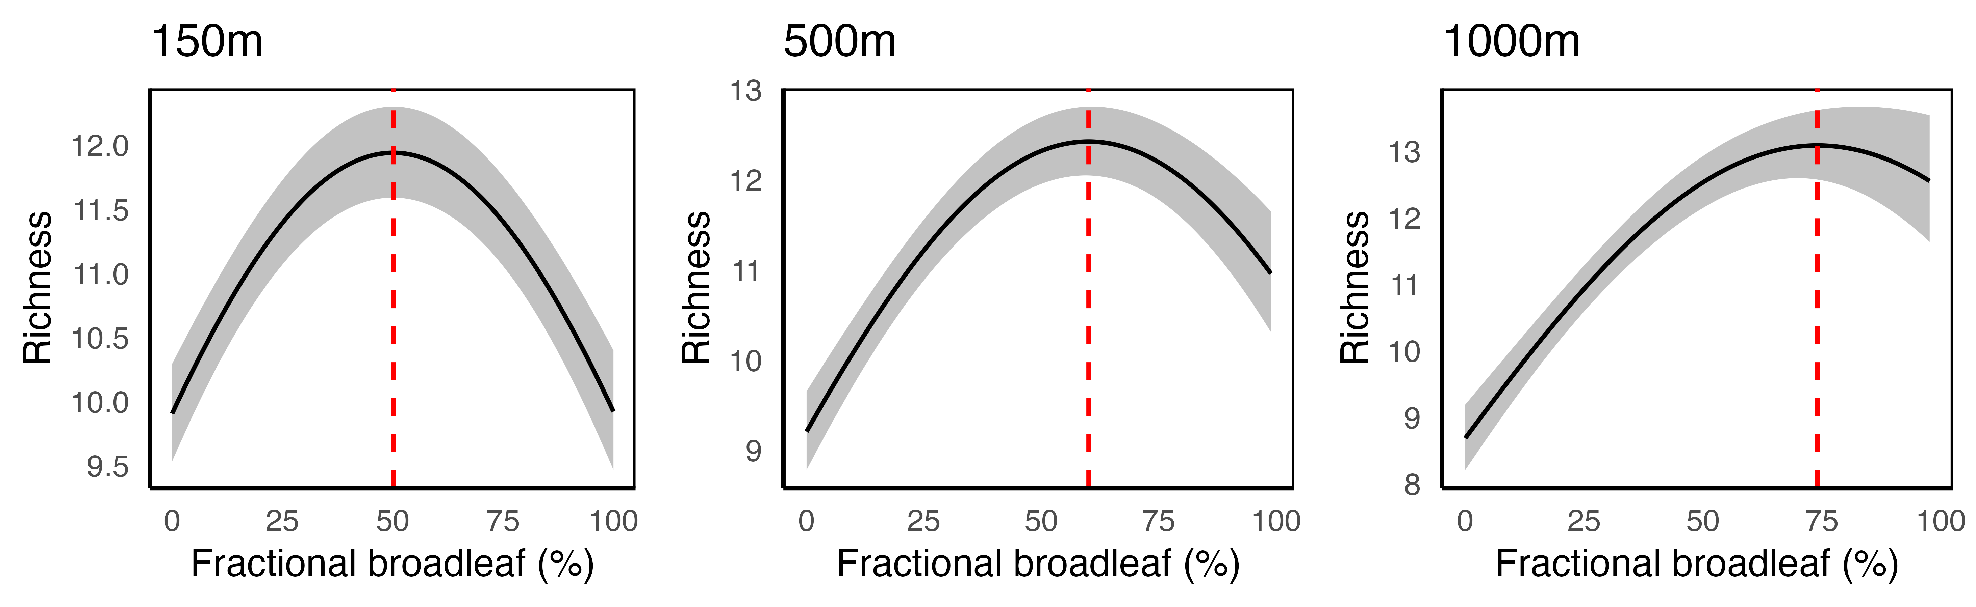
Figure 3: Relationship between fractional broadleaf cover and species richness at three spatial scales (150 m, 500 m, and 1000 m). The plots show an inverted U-shaped relationship, with species richness initially increasing with broadleaf cover and then decreasing after reaching a peak. The red dashed vertical lines indicate the broadleaf cover percentages at which species richness is maximized (50.11% at 150 m, 60.08% at 500 m, and 74.03% at 1000 m). The shaded areas represent 95% confidence intervals.

Shannon diversity
For Shannon diversity, the top linear mixed-effects model revealed a significant nonlinear inverted U-shaped relationship with percent broadleaf cover across all spatial scales (Figure 4). At 150 m, the linear term for fractional broadleaf cover was not significant ($β=-0.40$, SE = 0.25, $p=0.109$), but the quadratic term was significant ($β=-3.03$, SE = 0.25, $p<0.001$). The model explained 46.3% of the variance in Shannon diversity ($R_{\text{conditional}}^{2}=0.463$) peaking at 45.08% broadleaf cover. At 500 m, the linear term for fractional broadleaf cover was not significant ($β=0.44$, SE = 0.31, $p=0.162$), but the quadratic term was significant ($β=-1.93$, SE = 0.26, $p<0.001$). The model explained 46.5% of the variance in Shannon diversity ($R_{\text{conditional}}^{2}=0.465$), with Shannon diversity peaking at 49.54% broadleaf cover. At 1000 m, the linear term for fractional broadleaf cover was significant ($β=1.16$, SE = 0.33, $p<0.001$), as was the quadratic term ($β=-1.11$, SE = 0.25, $p<0.001$). The model explained 47.2% of the variance in Shannon diversity ($R_{\text{conditional}}^{2}=0.472$), with Shannon diversity peaking at 58.89% broadleaf cover.
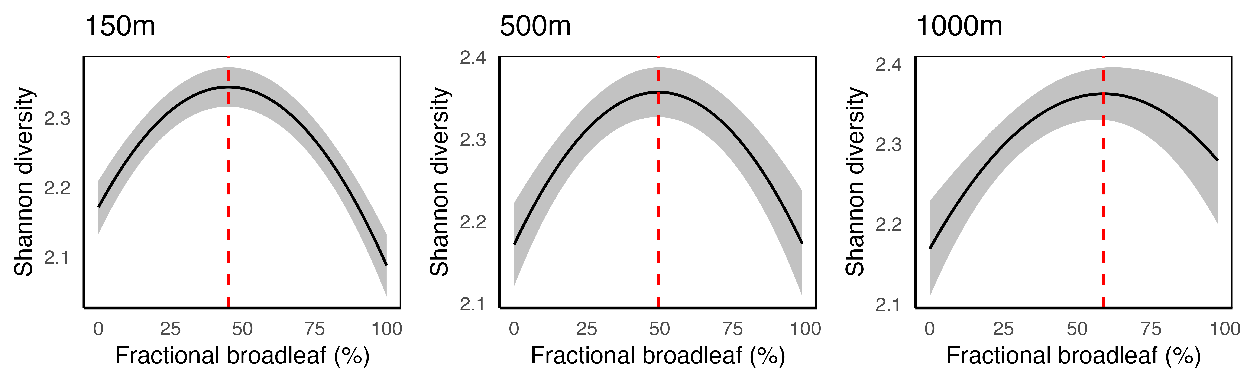
Figure 4: Relationship between fractional broadleaf cover and Shannon diversity at three spatial scales (150 m, 500 m, and 1000 m). The plots show an inverted U-shaped relationship, with Shannon diversity initially increasing with broadleaf cover and then decreasing after reaching a peak. The red dashed vertical lines indicate the broadleaf cover percentages at which Shannon diversity is maximized (45.08% at 150 m, 49.54% at 500 m, and 58.89% at 1000 m). The shaded areas represent 95% confidence intervals.

Pielou’s evenness
For Pielou’s evenness, the top linear mixed-effects models suggest a consistent decrease in Pielou’s evenness with increasing broadleaf cover across all spatial scales (Figure 5). At 150 m, the linear term for fractional broadleaf cover was significant ($β=-1.01$, SE = 0.25, $p<0.001$). The model explained 20.1% of the variance in Pielou’s evenness ($R_{\text{conditional}}^{2}=0.201$). At 500 m, the linear term for fractional broadleaf cover was significant ($β=-1.94$, SE = 0.24, $p<0.001$). The model explained 21.0% of the variance in Pielou’s evenness ($R_{\text{conditional}}^{2}=0.210$). At 1000 m, the linear term for fractional broadleaf cover was significant ($β=-2.17$, SE = 0.23, $p=0.032$). The model explained 21.8% of the variance in Pielou’s evenness ($R_{\text{conditional}}^{2}=0.218$).
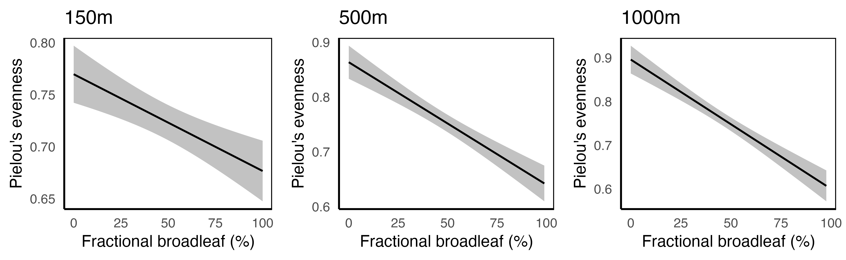
Figure 5: Relationship between fractional broadleaf cover and Pielou’s evenness at three spatial scales (150 m, 500 m, and 1000 m). The plots show a consistent negative relationship, with Pielou’s evenness decreasing as fractional broadleaf cover increases. The shaded areas represent 95% confidence intervals.
The top models, selected based on the lowest AIC values, consistently included fractional broadleaf cover, forest age, and their interaction terms as key predictors. Interaction terms between fractional deciduous cover and forest age were significant for species richness and Shannon diversity, but not for Pielou’s evenness. Older forests showed greater species richness and diversity than younger forests with equivalent broadleaf cover. The interaction models provided improved fit over models without interaction terms, as indicated by lower AIC values.
Model diagnostics indicated no significant issues with multicollinearity, with VIF values below 3 for all predictors. Residual plots and Moran’s I statistics suggested minimal spatial autocorrelation after accounting for site clusters.

Discussion

Summary of findings
This study examined the influence of varying degrees of mixedwood composition on breeding bird communities across a coniferous-deciduous gradient. Mixed-effects regression models suggested a significant relationship with between species richness and percent broadleaf cover. The number of bird species increased with broadleaf cover, peaking at different percentages depending on the spatial scale: 50.11% at 150 m, 60.08% at 500 m, and 74.03% at 1000 m. The Shannon diversity index had a similar nonlinear response to broadleaf cover, peaking at 45.08% at 150 m, 49.54% at 500 m, and 58.89% at 1000 m. In contrast, Pielou’s evenness index consistently decreased with increasing broadleaf cover across all spatial scales, suggesting less even species distribution in areas with higher proportions of broadleaf.
The inverted U-shaped response curves for species richness and Shannon diversity suggest that moderate levels of broadleaf cover can maximize bird diversity. This could be due to mixedwood stands providing a heterogeneous habitat that supports a variety of bird species with different ecological needs. However, the consistent decrease in Pielou’s evenness with increasing broadleaf cover implies that, while mixedwood stands support a higher number of species, these species are not relatively abundant. This could indicate dominance by a few species in areas with high broadleaf cover.
The scale-dependent relationship between percent broadleaf cover and bird diversity has implications for forest management and conservation practices. Our results suggest that at smaller spatial scales, the optimal broadleaf cover for maximizing bird diversity is lower than at larger scales (i.e. higher proportions of broadleaf are needed to achieve similar levels of diversity). As a result, mixedwood management strategies should be tailored to specific spatial scales to optimize bird diversity. For example, in small areas (150 to 500 m), maintaining approximately 50% broadleaf cover may be sufficient to maximize species richness, while management at broader scales (> 1000 m) might require up to 74% broadleaf cover. Understanding these scale-dependent relationships will allow for more precise and effective habitat management, ensuring that forest composition supports diverse and abundant bird communities across different spatial extents.

Next steps
As we move forward with this study, the immediate next steps are:
- Further explore the scale dependant relationships between broadleaf diversity and species diversity by repeating this analysis with land cover data summarized at larger scales (>1000 m)
- Incorporate SCANFI data from previous years (1985-2015). This will allow the inclusion of bird data from before 2010 and may lead to more robust model predictions.
- Repeat this analysis with broadleaf cover estimated from analogous land cover products including the High Resolution Tree Species Map for Canada (Hermosilla et al. 2022), the Canadian Satellite-Based Forest Inventory (SBFI) (Wulder et al. 2024), and the Common Attribute Schema for Forest Resource Inventories (CAS-FRI. Assess how the source of land cover data influences results, and whether a fusion of products can maximize predictiveness.
- Generate a bird diversity predictive map that overlays with the percent broadleaf layers. The map will be part of an interactive Google Earth Engine App.
- This analysis focused on taxonomic diversity, but future work will examine the response of functional diversity metrics to percent broadleaf cover. Where taxonomic diversity measures the distribution of species in a community, functional diversity measures the distribution of traits within a community and may better link to underlying ecological phenomena (Laliberté and Legendre 2010).
- Build individual species models with emphasis on species protected under the Species at Risk Act or that represent important functional guilds. Response to mixedwood composition is likely species specific, and different species may prefer different broadleaf cover percentages (e.g. 25%, 50%, 75%, etc.).
- As new bird point count data becomes available, the research will be expanded to include regions beyond Alberta, such as British Columbia, to determine if the observed broadleaf-diversity patterns hold across different forest compositions.
- The results will be described in a manuscript submitted to a high-impact science journal.

References

Bartoń, K. 2020. MuMIn: Multi-model inference. manual.
Bates, D., M. Mächler, B. Bolker, and S. Walker. 2015. Fitting linear mixed-effects models using lme4. Journal of Statistical Software 67:1–48.
Boreal Avian Modelling Project. 2018. Boreal Avian Modelling Project.
Brandt, J. P., M. D. Flannigan, D. G. Maynard, I. D. Thompson, and W. J. A. Volney. 2013. An introduction to Canada’s boreal zone: Ecosystem processes, health, sustainability, and environmental issues. Environmental Reviews 21:207–226.
Burnham, K. P., and D. R. Anderson. 2002. Model selection and multimodel inference: A practical information-theoretic approach. Springer, New York.
Cumming, S. G., D. Stralberg, K. L. Lefevre, P. Sólymos, E. M. Bayne, S. Fang, T. Fontaine, D. Mazerolle, F. K. A. Schmiegelow, and S. J. Song. 2014. Climate and vegetation hierarchically structure patterns of songbird distribution in the Canadian boreal region. Ecography 37:137–151.
Felton, A., P.-O. Hedwall, R. Trubins, J. Lagerstedt, A. Felton, and M. Lindbladh. 2021. From mixtures to monocultures: Bird assemblage responses along a production forest conifer-broadleaf gradient. Forest Ecology and Management 494:119299.
Franklin, J. F., and K. N. Johnson. 2012. A Restoration Framework for Federal Forests in the Pacific Northwest. Journal of Forestry 110:429–439.
Guindon, L., F. Manka, D. L. P. Correia, P. Villemaire, B. Smiley, P. Bernier, S. Gauthier, A. Beaudoin, J. Boucher, and Y. Boulanger. 2024. A new approach for Spatializing the CAnadian National Forest Inventory (SCANFI) using Landsat dense time series. Canadian Journal of Forest Research:cjfr–2023–0118.
Hijmans, R. J. 2024. Terra: Spatial data analysis. manual.
Hobson, K. A., and E. Bayne. 2000. Breeding Bird Communities in Boreal Forest of Western Canada: Consequences of “Unmixing” the Mixedwoods. The Condor 102:759–769.
Huberman, Y. L., and B. N. I. Eskelson. 2023. Conifer performance, stand productivity, and understory cover in varying densities of mixed conifer-broadleaf stands in southwestern British Columbia. Canadian Journal of Forest Research 53:430–443.
Laliberté, E., and P. Legendre. 2010. A distance-based framework for measuring functional diversity from multiple traits. Ecology 91:299–305.
Lüdecke, D., M. Ben-Shachar, I. Patil, P. Waggoner, and D. Makowski. 2021. Performance: An R Package for Assessment, Comparison and Testing of Statistical Models. Journal of Open Source Software 6:3139.
MacPhail, A., M. Becker, and E. Knight. 2024. wildRtrax: Environmental sensor data management and analytics to and from WildTrax.
Maltman, J. C., T. Hermosilla, M. A. Wulder, N. C. Coops, and J. C. White. 2023. Estimating and mapping forest age across Canada’s forested ecosystems. Remote Sensing of Environment 290:113529.
Nakagawa, S., and H. Schielzeth. 2013. A general and simple method for obtaining R2 from generalized linear mixed-effects models. Methods in Ecology and Evolution 4:133–142.
Natural Regions Committee. 2006. Natural regions and subregions of Alberta. Compiled by DJ Downing; WW Pettapiece. Government of Alberta, Edmonton, Alberta, Canada.
R Core Team. 2020. R: A language and environment for statistical computing. manual, Vienna, Austria.
Venier, L. A., I. D. Thompson, R. Fleming, J. Malcolm, I. Aubin, J. A. Trofymow, D. Langor, R. Sturrock, C. Patry, R. O. Outerbridge, S. B. Holmes, S. Haeussler, L. D. Grandpré, H. Y. H. Chen, E. Bayne, L. De Grandpré, H. Y. H. Chen, E. Bayne, A. Arsenault, and J. P. Brandt. 2014. Effects of natural resource development on the terrestrial biodiversity of Canadian boreal forests. Environmental Reviews 22:457–490.

